 

Internship Project Report on

**Garbage Classification Using IBM Cloud**

SUBMITTED BY:

AKRITI GOYAL 4BD18CS004 BHUMIKA G U 4BD18CS015

CHETAN B B 4BD18CS017

K YASHODA 4BD18CS031



DEPARTMENT OF COMPUTER SCIENCE AND ENGINEERING

BAPUJI INSTITUTE OF ENGINEERING AND TECHNOLOGY DAVANGERE

ACADEMIC YEAR: 2021-2022

**CONTENTS**

**CHAPTERS PAGE NO’S**

# INTRODUCTION 01

* 1. Overview
  2. Purpose

# LITERATURE SURVEY 02

* 1. Existing Problem
  2. Proposed Solution

# THEORETICAL ANALYSIS 03

* 1. Block Diagram
  2. Hardware and Software Design

# EXPERIMENTAL INVESTIGATIONS 04

* 1. Analysis while working
  2. User interface

# FLOWCHART 05-06

# RESULT 07-09

# ADVANTAGES AND DISADVANTAGES 10

# APPLICATIONS 11

# CONCLUSION 12

# FUTURE SCOPE 12

**CHAPTER 1**

**INTRODUCTION**

# OVERVIEW

Currently, the world generates more than 2 billion tons of municipal solid waste annually, which is huge damage to the ecological environment. Waste production will increase by 70% if current conditions persist. Recycling is becoming an indispensable part of a sustainable society. However, the whole procedure of recycling demands a huge hidden cost, which is caused by selection, classification, and processing of the recycled materials. Even though consumers are willing to do their own garbage sorting nowadays in many countries, they might be confused about how to determine the correct category of the garbage when disposing of a large variety of materials.

# PURPOSE

The purpose of object detection based on image recognition is to identify whether specific objects appear in an image. After the object is identified, the next step is to determine its location and size using a special adjustable frame. Object detection and identification have been widely used in artificial intelligence systems for robotics, electronics, road safety, autonomous driving, intelligent transportation systems, and content identification. Deep learning techniques have enabled advanced feature recognition directly from image data, leading to considerable progress in general image detection and object classification.

**CHAPTER 2**

**LITERATURE SURVEY**

# EXISTING SYSTEM

Humans generated more than 2 billion tons of solid waste in 2016 and by 2050, that could rise to 3.4 billion tons, according to the World Bank. About 12% of all municipal waste in 2016 was plastic, 242 million tons of it. The solution could lie in new technologies and a change in social behavior that reduces and even eliminates the need for landfills and incinerators. Sorting trash can be an unpleasant job, one reason why a lot of rubbish ends up in developing countries with lower wages.

# PROPOSED SYSTEM

Finding an automatic way to do the recycling is now of great value to an industrial and information-based society, which has not only environmental effects but also beneficial economic effects. Since last decade the industry of artificial intelligence has welcomed its third wave with a sufficient database. Deep learning began to show its high efficiency and low complexity in the field of computer vision. Overall, this study is to identify a single object in an image and to classify it into one of the recycling categories, such as mental, paper, and plastic.

**CHAPTER 3**

**THEORETICAL ANALYSIS**

# BLOCK DIAGRAM

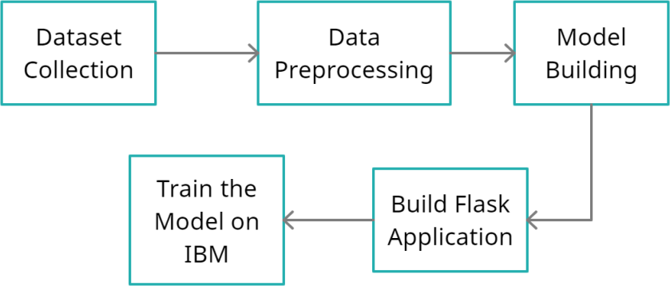

Image pre- processing

**Figure 3.1.1: Block Diagram of Project**

# HARDWARE AND SOFTWARE DESIGNING

**HARDWARE DESIGNING:**

The hardware required for the development of this project is:

* + - Processor : Intel® CoreTM i5-9300H
    - Processor speed : 2.4GHz
    - RAM Size : 8 GB DDR
    - System Type : X64-based processor

**SOFTWARE DESIGNING:**

The software required for the development of this project is:

* + - Desktop GUI : Anaconda Navigator
    - Operating System : Windows 10(and other higher version)
    - Front end : HTML,CSS,JAVASCRIPT
    - Programming Language : PYTHON
    - Cloud Computing Service : IBM Cloud Services

**CHAPTER 4**

**EXPERIMENTAL ANALYSIS**

# ANALYSIS OR INVESTIGATION MADE WHILE WORKING

Humans generated more than 2 billion tons of solid waste in 2016 and by 2050, that could rise to 3.4 billion tons, according to the World Bank. About 12% of all municipal waste in 2016 was plastic, 242 million tons of it. The solution could lie in new technologies and a change in social behavior that reduces and even eliminates the need for landfills and incinerators. Sorting trash can be an unpleasant job, one reason why a lot of rubbish ends up in developing countries with lower wages.

# Convolutional Neural Network

A Convolutional Neural Network (ConvNet/CNN) is a Deep Learning algorithm which can take in an input image, assign importance (learnable weights and biases) to various aspects/objects in the image and be able to differentiate one from the other. The pre- processing required in a ConvNet is much lower as compared to other classification algorithms. While in primitive methods filters are hand-engineered, with enough training, ConvNets have the ability to learn these filters/characteristics.

# USER INTERFACE (Python Flask):

Flask is a micro web framework written in Python.Extensions exist for object-relational mappers, form validation, upload handling, various open authentication technologies and several common framework related tools. Flask is used for the backend, but it makes use of a templating language called Jinja2 which is used to create HTML, XML or other markup formats that are returned to the user via an HTTP request. Flask offers a diversified working style while Django offers a Monolithic working style. It is designed as a web framework for restful API development

**CHAPTER 5**

**FLOWCHART**

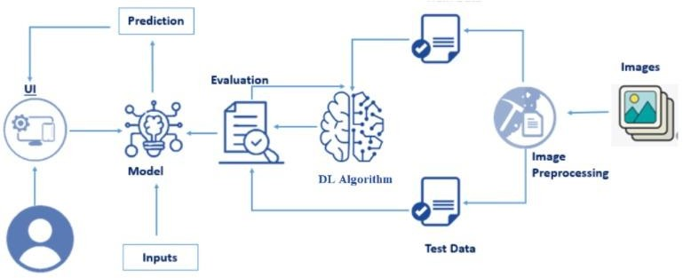

**Figure 5.1: Flowchart of the Project**

**Project Flow:**

1. Install Required Libraries.
2. Image Collection.
   * Collect the dataset or Create the dataset
3. Image Pre- processing.
   * Import the Libraries.
   * Importing the dataset.
   * Understanding Data Type and Summary of features.
   * Take care of missing data & create columns.
   * Data Visualization.
   * Drop the column from dataframe ,merge the dataframes.
   * Observing Target,Numerical and Categorical Columns
   * Label Encoding & Splitting the Dataset into Dependent and Independent variables
   * Splitting Data into Train and Test.
4. Model Building
   * Training and testing the model
   * Evaluation of Model
   * Saving the Model
5. Application Building
   * Create an HTML file
   * Build a Python Code
6. Final UI
   * Dashboard Of the flask app.

**CHAPTER 6**

**RESULTS**

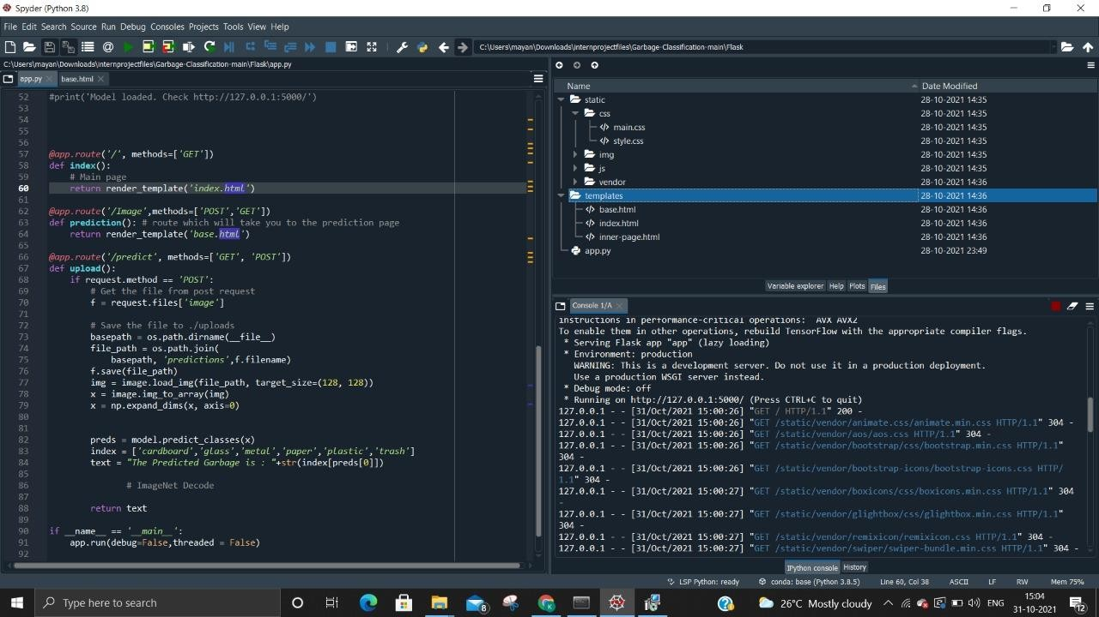

**Figure 6.1: Output Page**

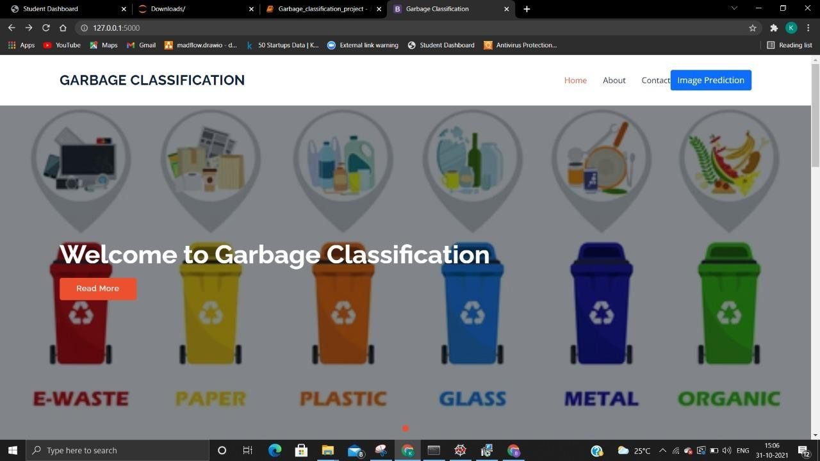

**Figure 6.2: Home Page**

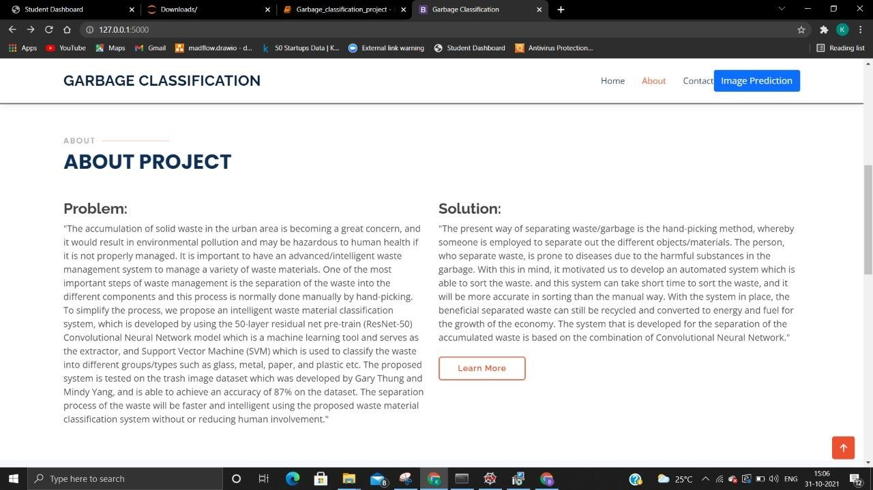

**Figure 6.3: About page**

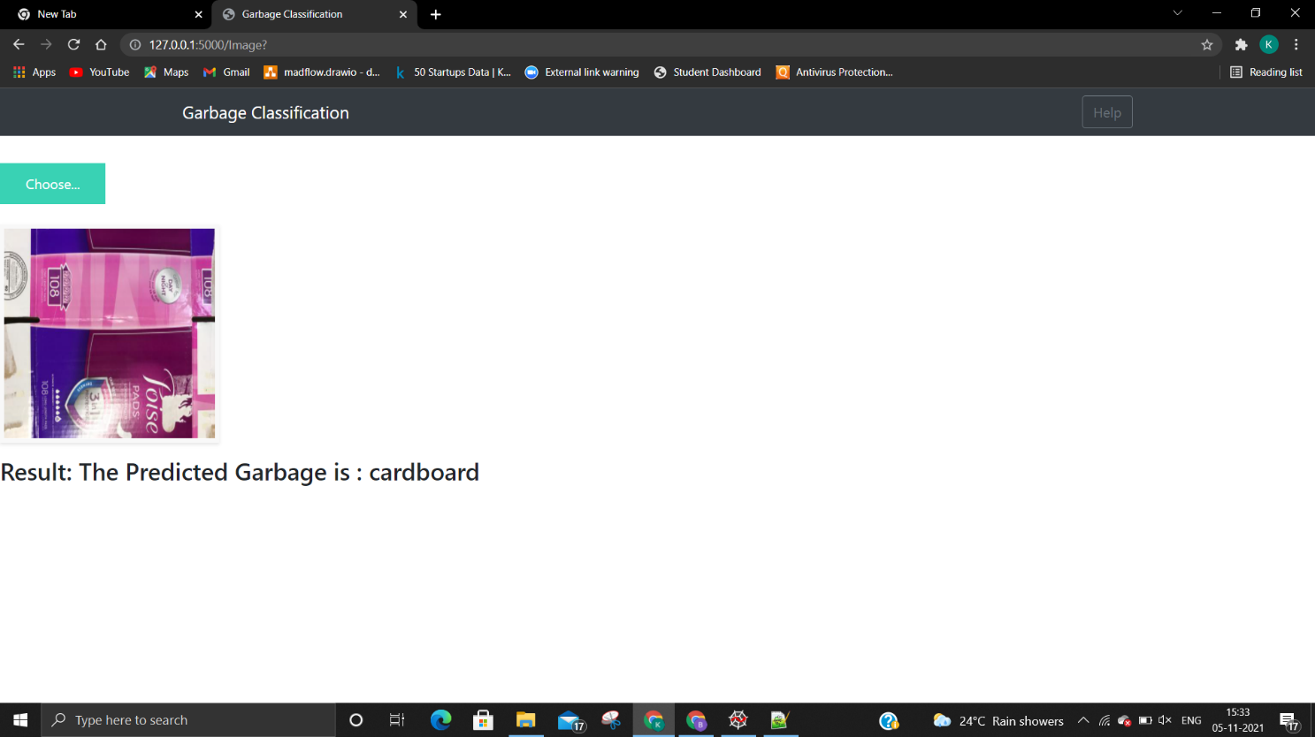

**Figure 6.4: Prediction Page**

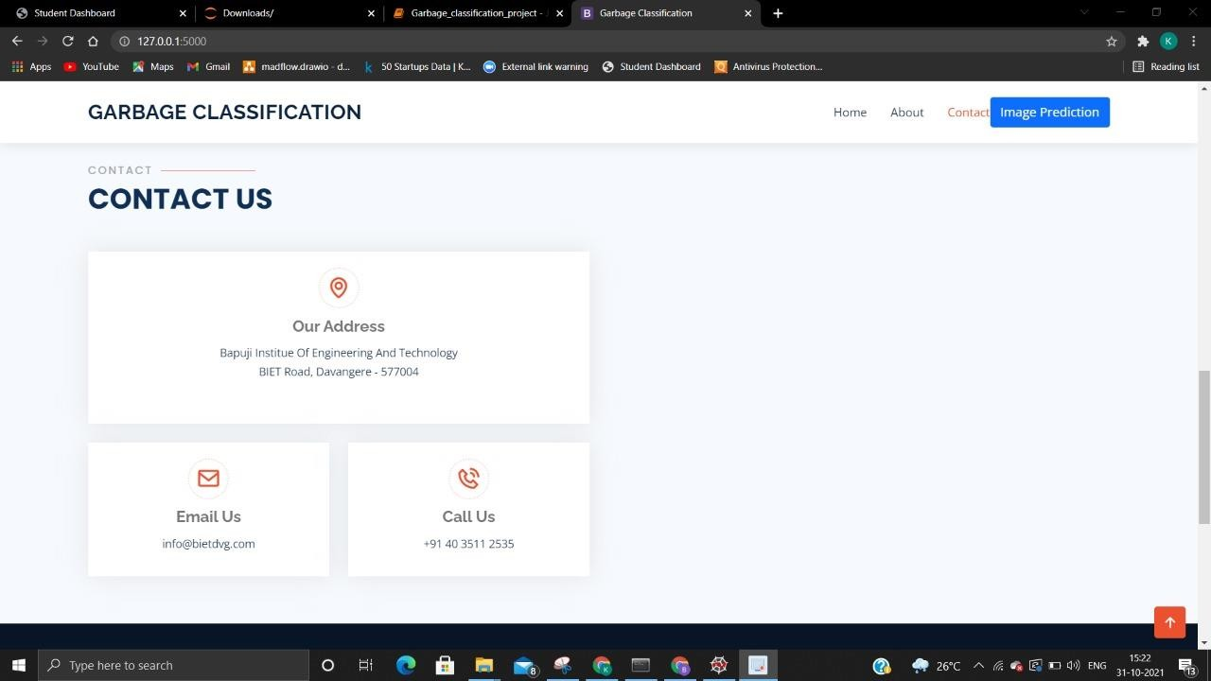

**Figure 6.5: Footer page**

**CHAPTER 7**

**ADVANTAGES AND DISADVANTAGES**

# Advantages

1. This new method for identifying waste enables the development of a ready-made digital solution to recognize the equipment reported for collection based on customer images. As an essential tool for collection planning, it allows for the potential valorization of the secondary raw material content.
2. It also takes advantage of the widespread use of smartphones and the commonplace ability to take and upload photos, which was an unrealistic expectation until recently.
3. The proposed system of taking, uploading, and recognizing pictures to prepare a waste collection plan can also be utilized in municipal collection centers or in electronic marketplaces where e-waste is stored. In such cases, more waste equipment could be identified using faster R-CNN, as shown in this study.

# Disadvantages

The accuracy of the whole system majorly depends on the dataset used for classifying purposes. As trash can consist of a wide range of items that also appear different depending on how, when and for how long they have been disposed of, the dataset we use has some limitations. To increase the accuracy of our system, more real data of actual piles of garbage are also required to train our model better

**CHAPTER 8**

**APPLICATIONS**

1. Our study proposes a novel application with a deep learning CNN and faster R-CNN for the identification of waste equipment in household collection.
2. This concept would use digital image sharing to facilitate the exchange of information between a collection company and an individual requesting waste retrieval.
3. An additional advantage of such a system is the widespread use and social acceptance of online solutions and smartphone applications. Automated visual waste recognition would benefit both the waste collection companies (by the valorization of waste and recognition of the collection dimensions) and the residents who could conveniently request retrieval by merely sending a photo of the waste equipment. The algorithm and application could be operated on a server or through a mobile application.

**CHAPTER 9**

**CONCLUSION AND FUTURESCOPE**

# Conclusion

This research presents a novel approach to photographic identification and categorization of e-waste by using CNN to classify the type of e-waste, and using R-CNN to detect the category and size of waste equipment in images. The classification and detection algorithms utilized showed high identification efficiency. Recognition accuracy could be increased further by increasing the number of images in the learning set to several hundred or even several thousand. The application of deep learning CNN and faster R-CNN resulted in waste equipment identification with an accuracy of 90–96.7%. On average, the R-CNN network provided lower accuracy (90%) than the best CNN, but allowed for the identification and determination of the size of the object in the image.

# Future scope

Deep learning techniques have enabled advanced feature recognition directly from image data, leading to considerable progress in general image detection and object classification. This method could also be applied to other bulky waste categories for which similar challenges are encountered in waste collection.